Australian Service Excellence Awards
2022 Individual Nomination Questionnaire

Your Name (Nominator):
Nominee Name:
Organisation Name:
Award Category:

Judging Criteria
There are five sections in this document that provide you the opportunity to explain why the Nominee should be considered for the relevant award category. Four of these sections reflect the below service perspectives, that underpin the International Customer Service Standard (ICSS: 2020-2025). Under each section we have provided some guidance on what you may like to include.

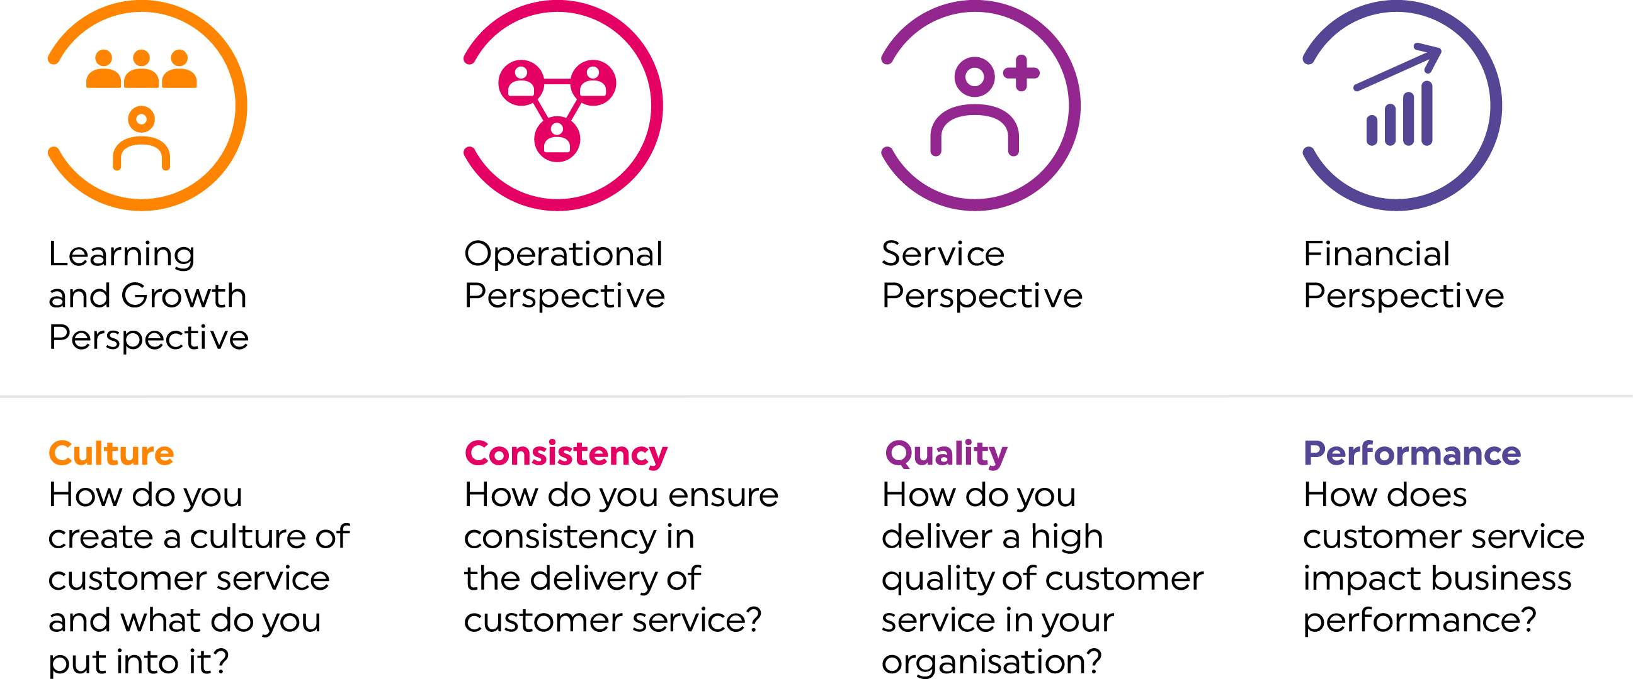

- Overview of nominee and their role
Please provide an explanation of the nominee's role and why you believe they should be considered for an award (approx 250 words).

- Learning and growth perspective
How has the nominee improved the skills and talents of themselves and those around them in their role? How have they contributed to the organisation delivering customer service excellence? (approx 250 words)

- Operational perspective
How has the nominee ensured a consistent level of customer service within the organisation? How has the nominee innovated in their role to ensure a better level of customer service? How have they contributed to after sales service delivery, if applicable? (approx 250 words)

- Service perspective
How has the nominee worked with customers, suppliers and partners to deliver a better quality of product or service for the organisation? If applicable, how have they used market trends and industry best practice to deliver better customer service? How have they built long-term relationships with customers? (approx 250 words)

5. Finance and governance perspective
How has the nominee created growth in revenue, cost efficiencies and/or profit for the organisation in delivering superior customer service? If applicable, how has corporate social responsibility played a role in what they do? (approx 250 words)

